Contents
INTRODUCTION 1
DESIGN DECISIONS 3
SQL IMPLEMENTATION 4
User Management and Database Security 16
Conclusion 18

INTRODUCTION
The aim of our project is to design and implement a Public Health Service Database System using MySQL. The system is intended to manage and organize important healthcare data such as patient records, health workers, visits, diagnoses, and treatments in an efficient and structured manner.
Our project focuses on applying database design principles, including the creation of tables, defining relationships using primary and foreign keys, and implementing SQL queries to retrieve and manipulate data. Additionally, the project demonstrates database security through user management by controlling access to the system.
This system is important in real-world healthcare environments as it ensures proper data organization, quick access to information, and protection of sensitive patient records.

Our physical data model represents how the database is structured in MySQL. It shows the tables, their attributes, and the relationships between them. The relationships are implemented using foreign keys to ensure data consistency.
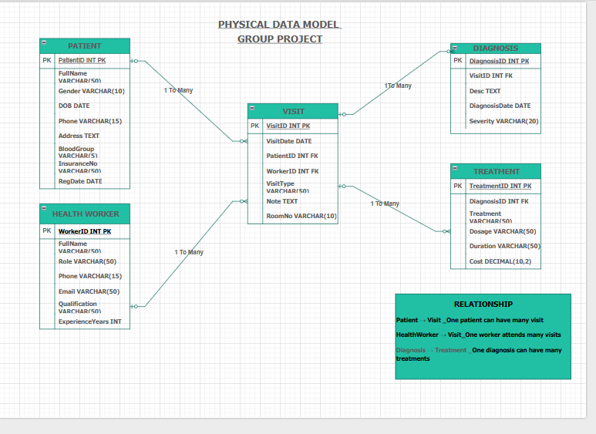

DESIGN DECISIONS
The database was designed using five main tables: Patient, HealthWorker, Visit, Diagnosis, and Treatment. Each table was structured carefully to represent real-world entities in a public health system.
Appropriate data types were selected for each attribute. For example, INT was used for IDs because it allows efficient indexing and identification of records. VARCHAR was used for names and text fields to store variable-length strings. DATE was used for fields such as date of birth and visit dates to ensure proper date handling. DECIMAL was used for cost to allow accurate storage of monetary values.
Primary keys were assigned to uniquely identify each record in a table, while foreign keys were used to establish relationships between tables. For example, the Visit table references Patient and HealthWorker, while the Diagnosis table references Visit, and the Treatment table references Diagnosis.
These design decisions ensure data integrity, reduce redundancy, and maintain consistency across the database.

SQL IMPLEMENTATION
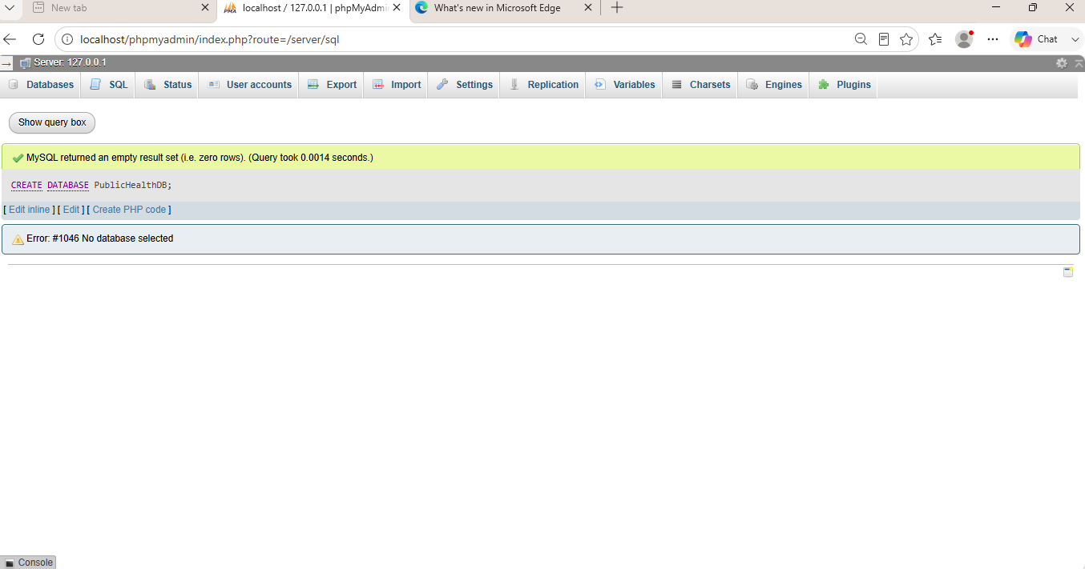
This screenshot shows the creation of the PublicHealthDB database, which serves as the main storage for all system data.
This screenshot shows the creation of tables including Patient, HealthWorker, Visit, Diagnosis, and Treatment. Each table includes fields and constraints such as primary keys and foreign keys.
Patient table
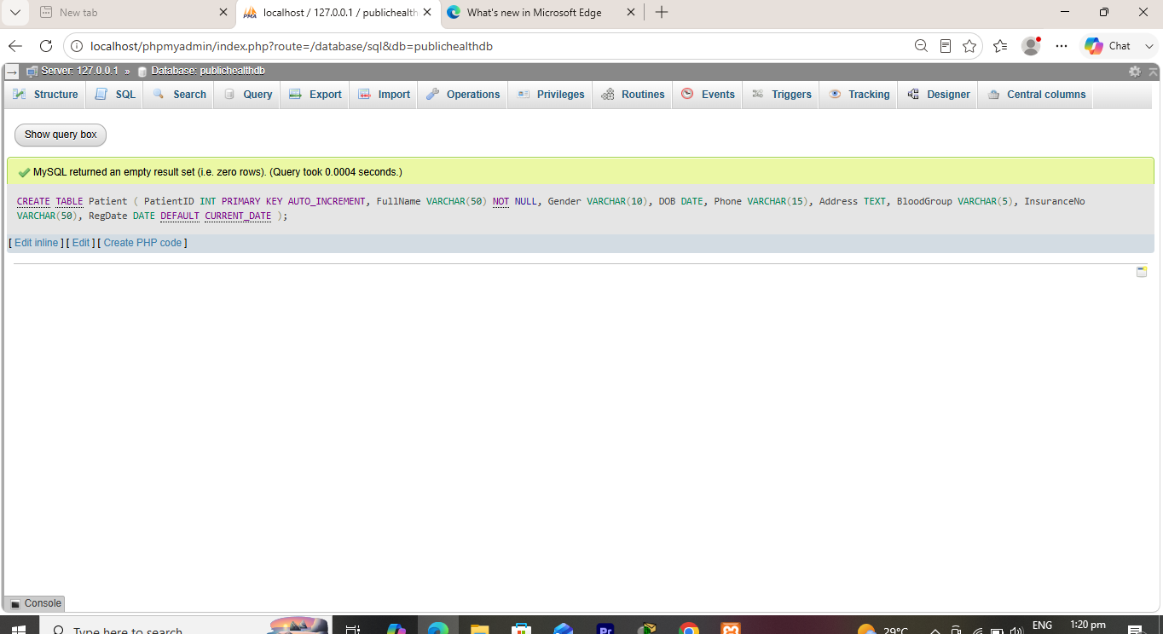
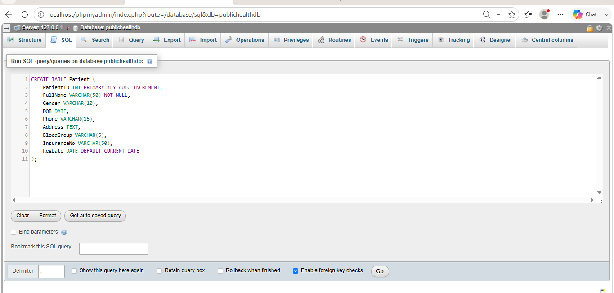
HEALTHWORKER
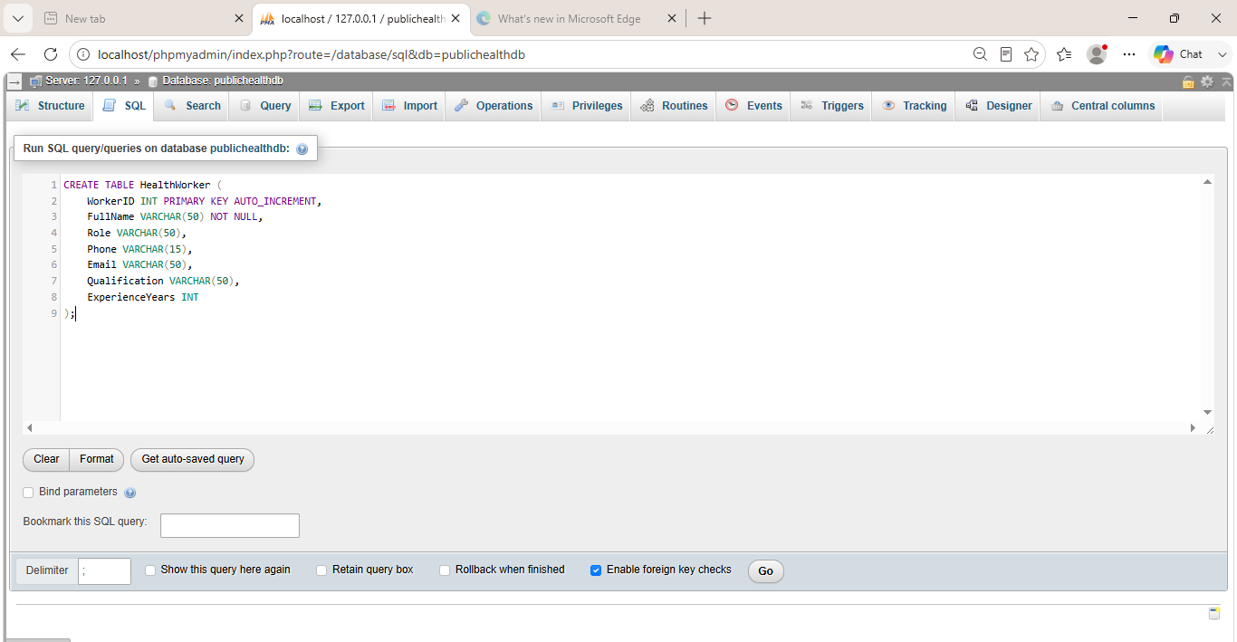
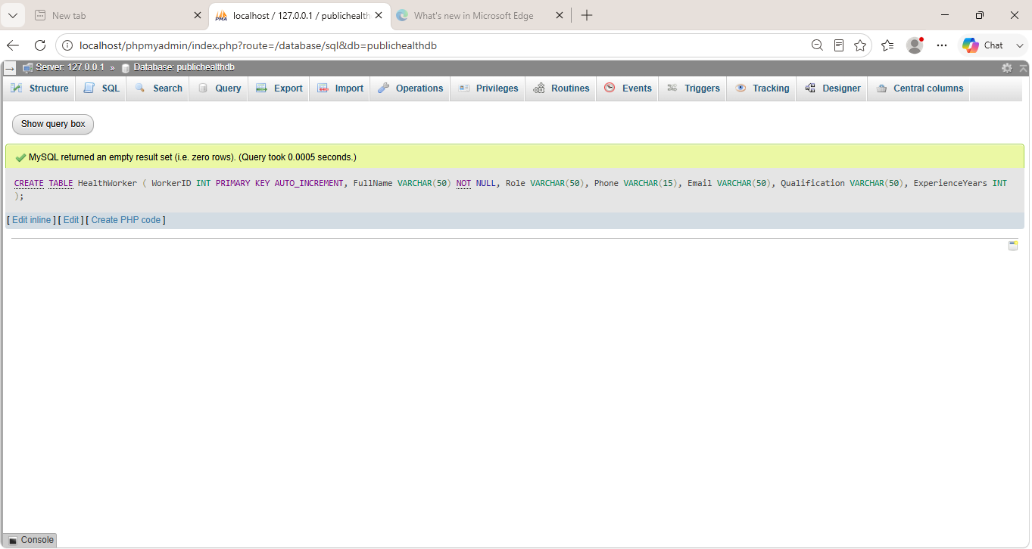

VISIT
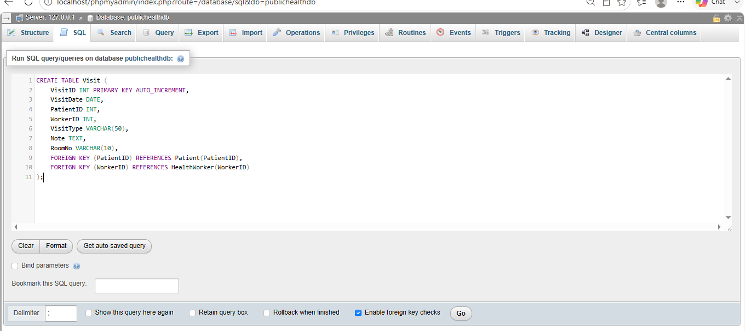
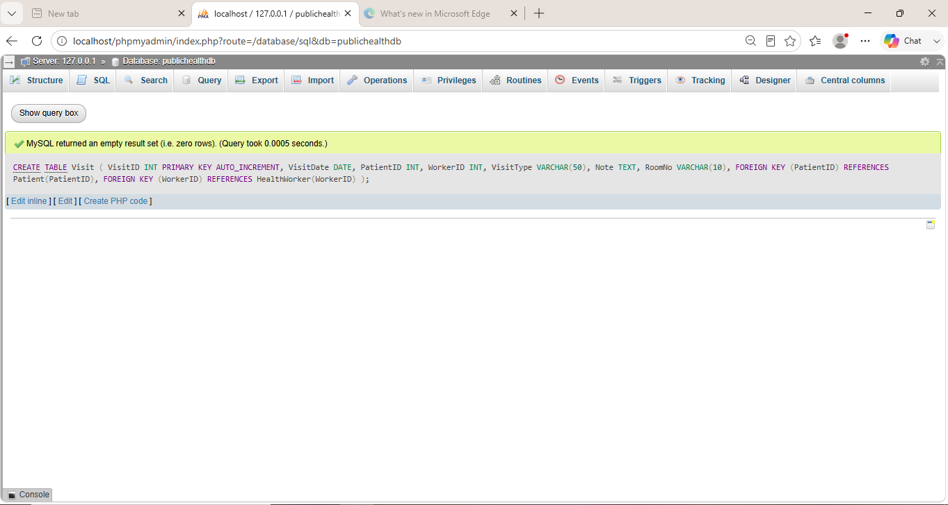
DIAGNOSIS
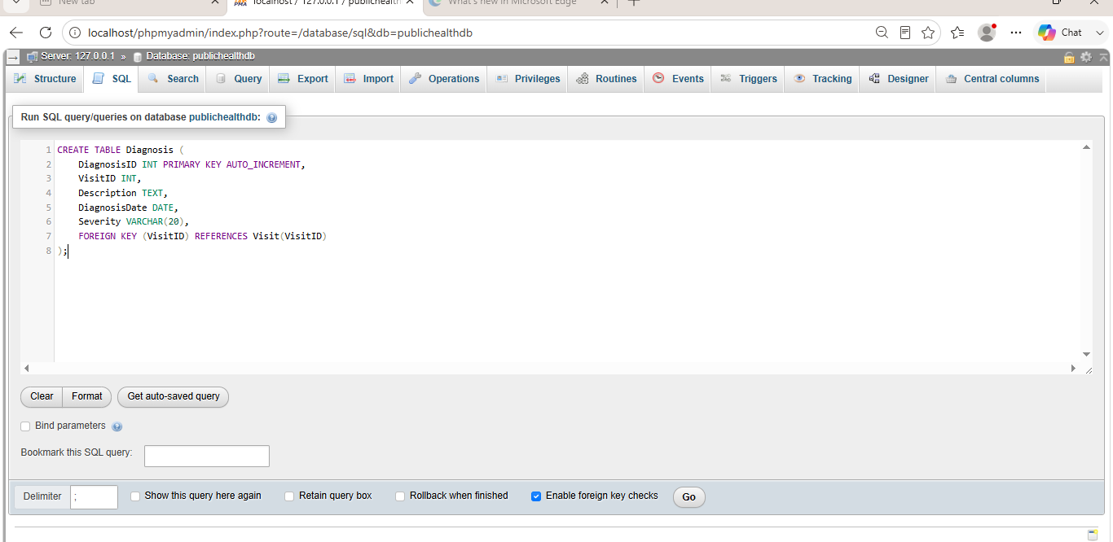

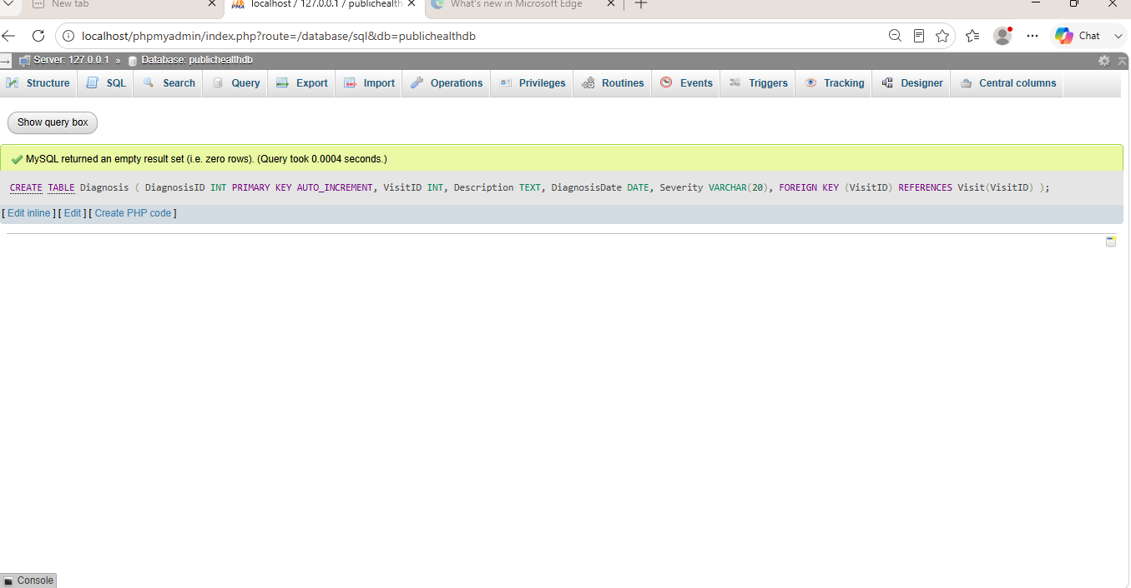
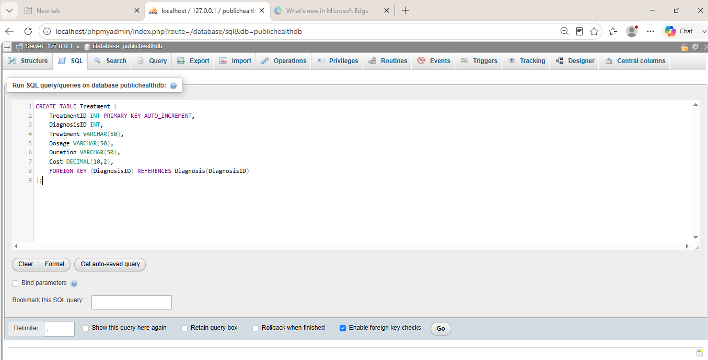
TREATMENT

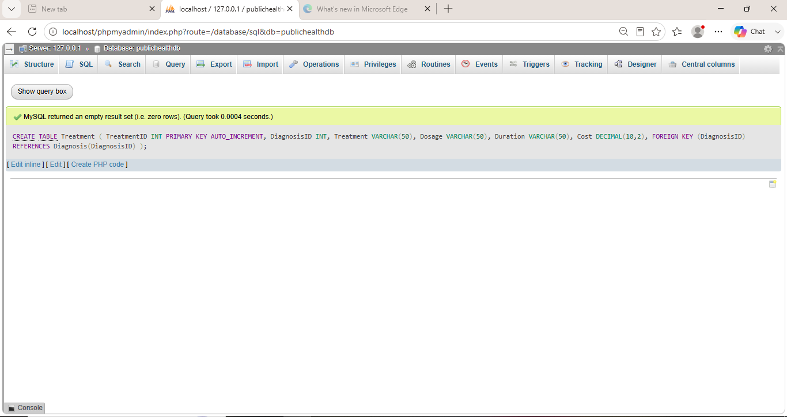

This screenshot shows the insertion of sample data into the tables. At least 20 records were inserted into each table as required by the assignment.
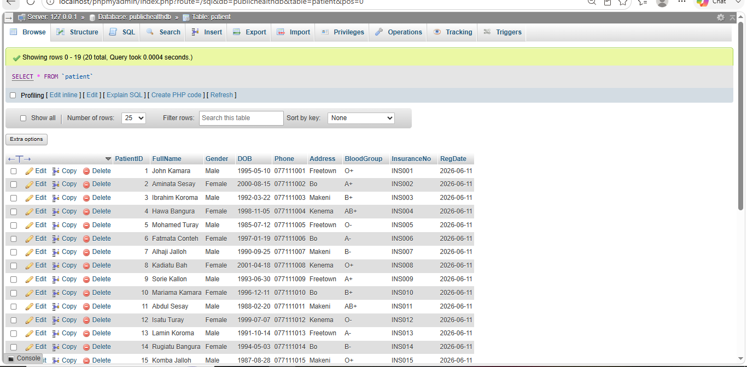
PATIENT TABLE RECORD
HEALTHWORKER TABLE RECORD
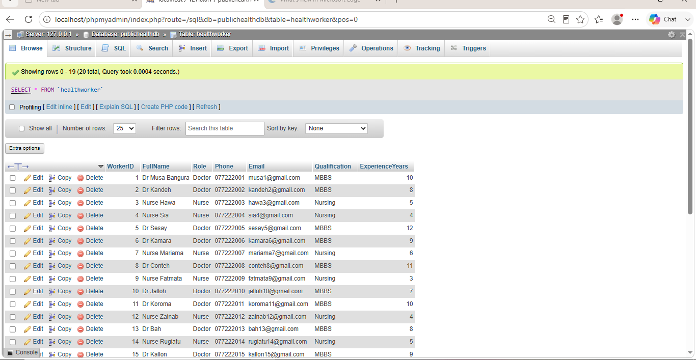

VISIT TABLE RECORD
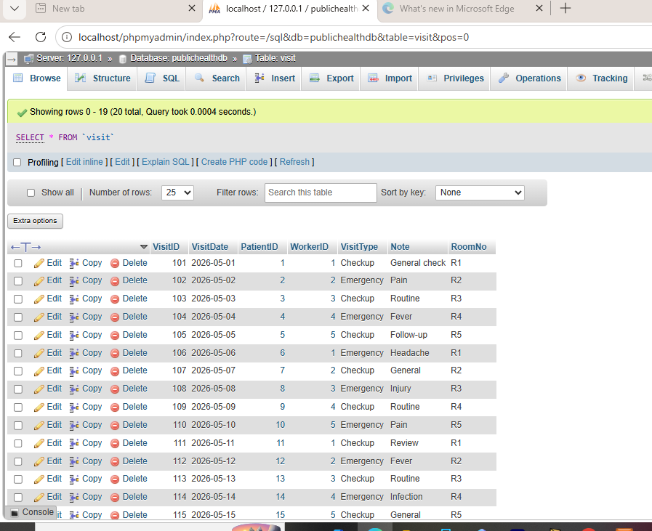

DIAGNOSIS RECORD TABLE
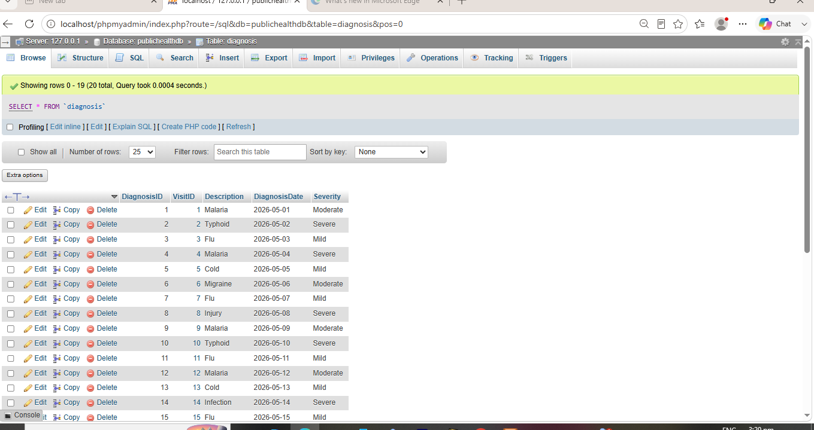

TREATMENT RECORD TABLE
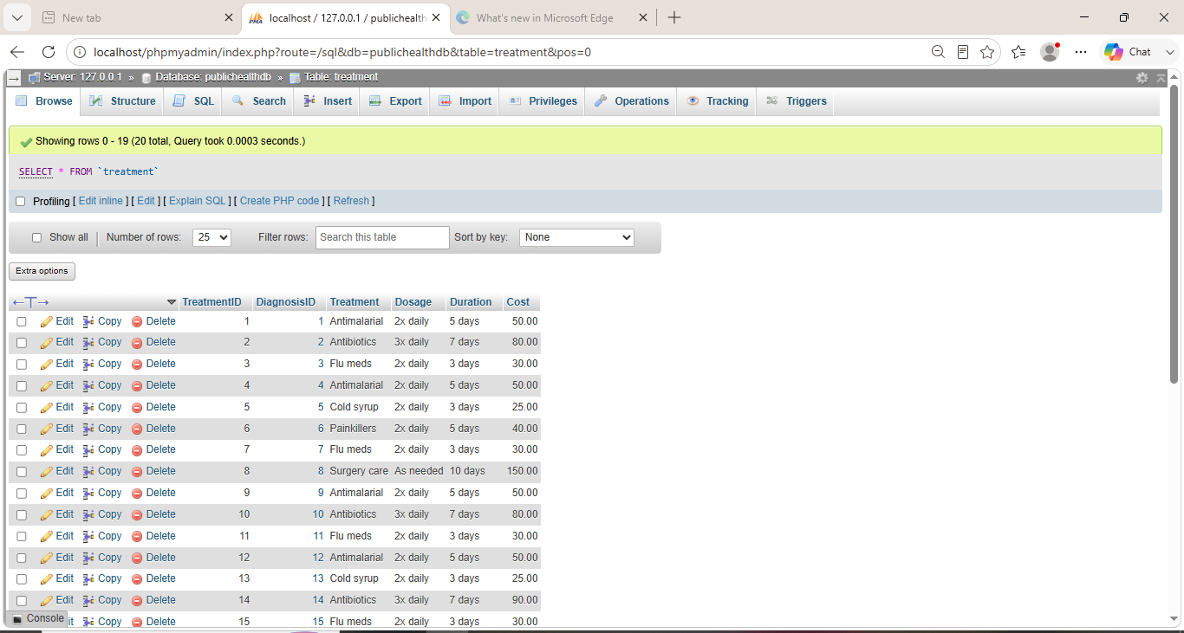

This screenshot shows the execution of SQL queries such as SELECT, WHERE, ORDER BY, COUNT, SUM, AVG, LIMIT, FORM, and JOIN, which are used to retrieve and analyze data.
WHERE
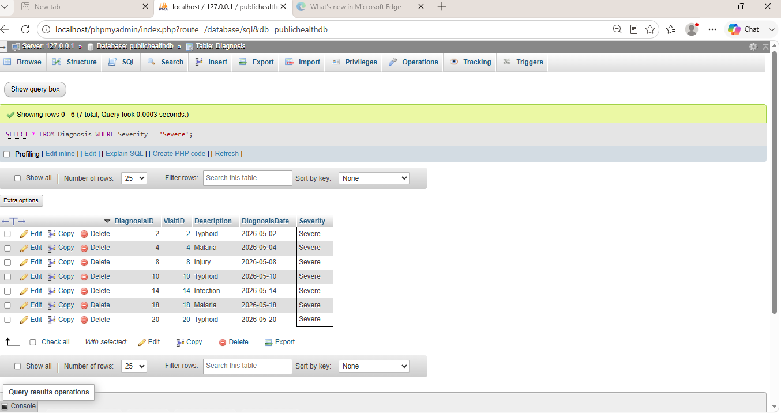
ORDER
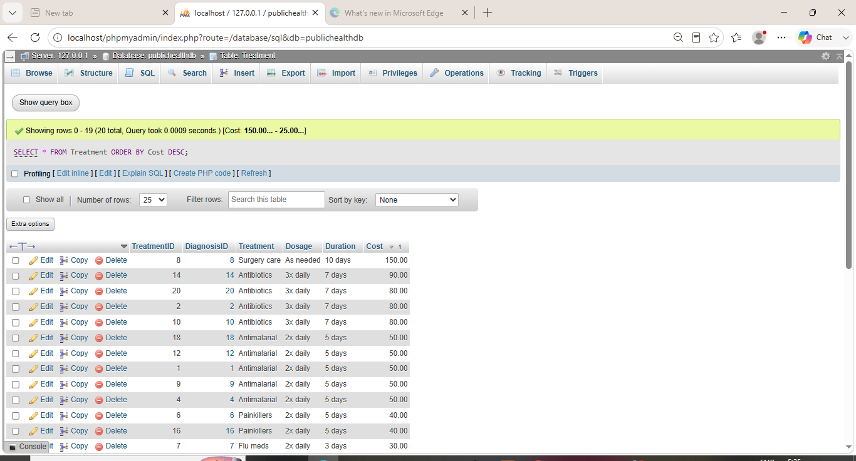
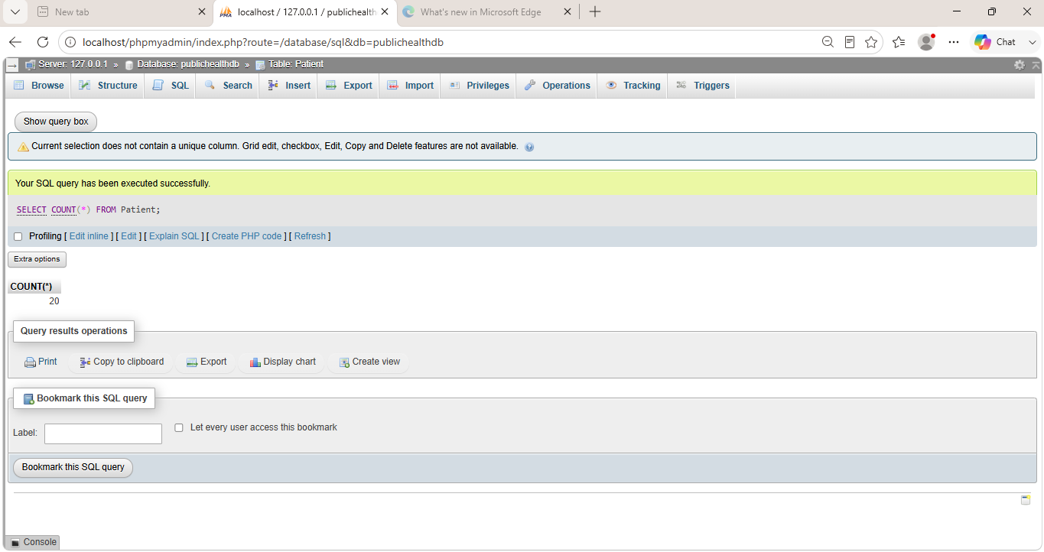
COUNT

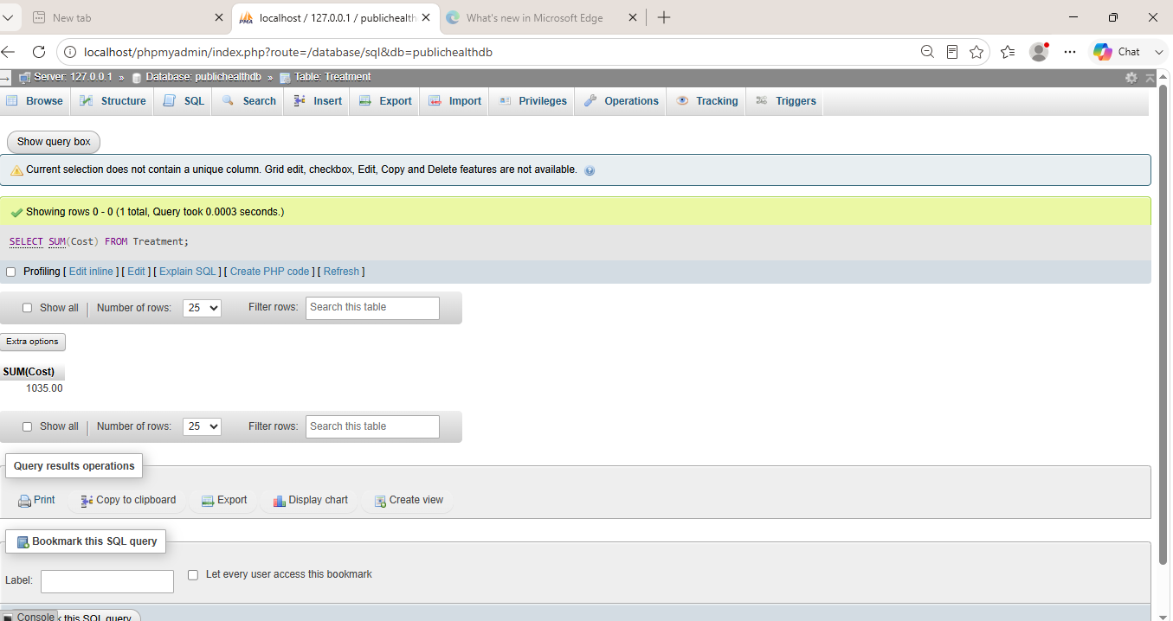
SUM

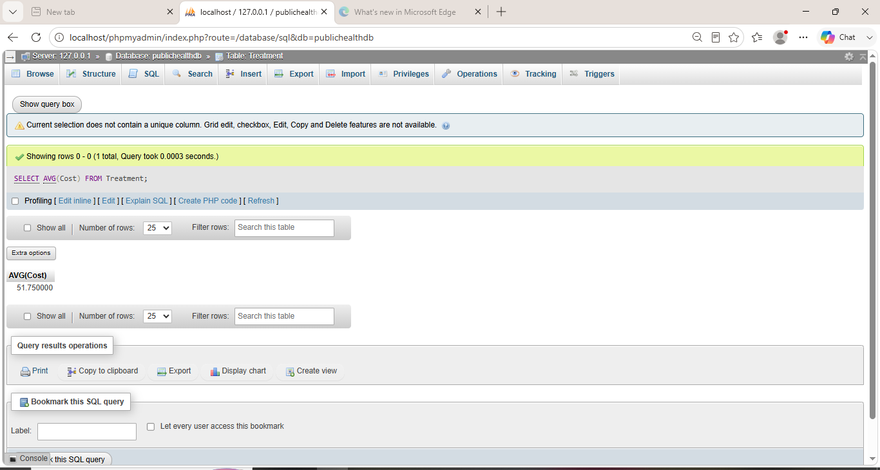
AVG

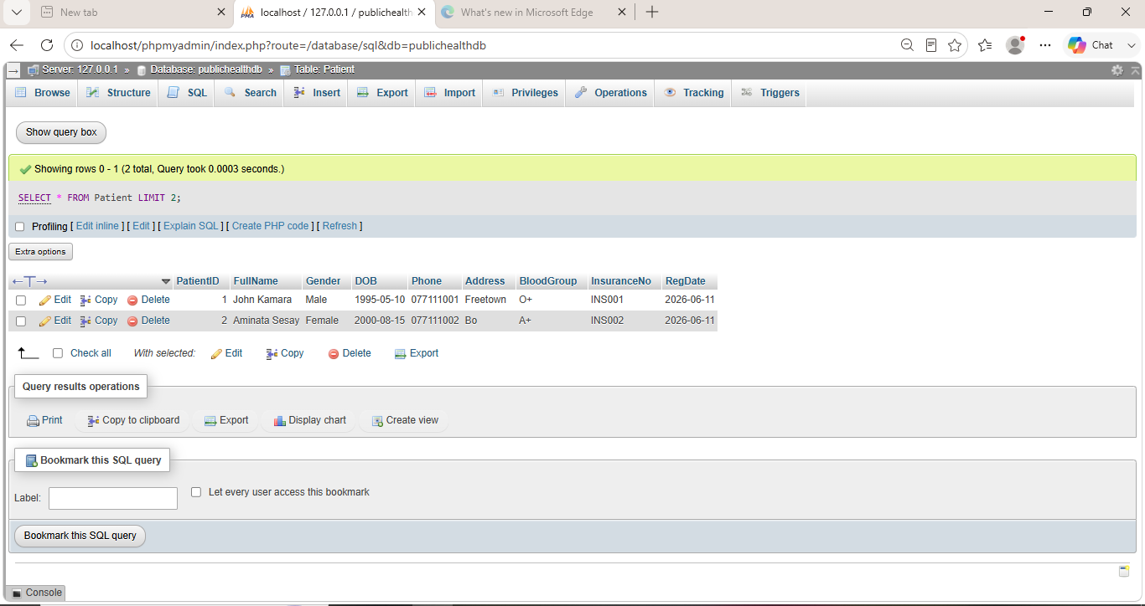
LIMIT

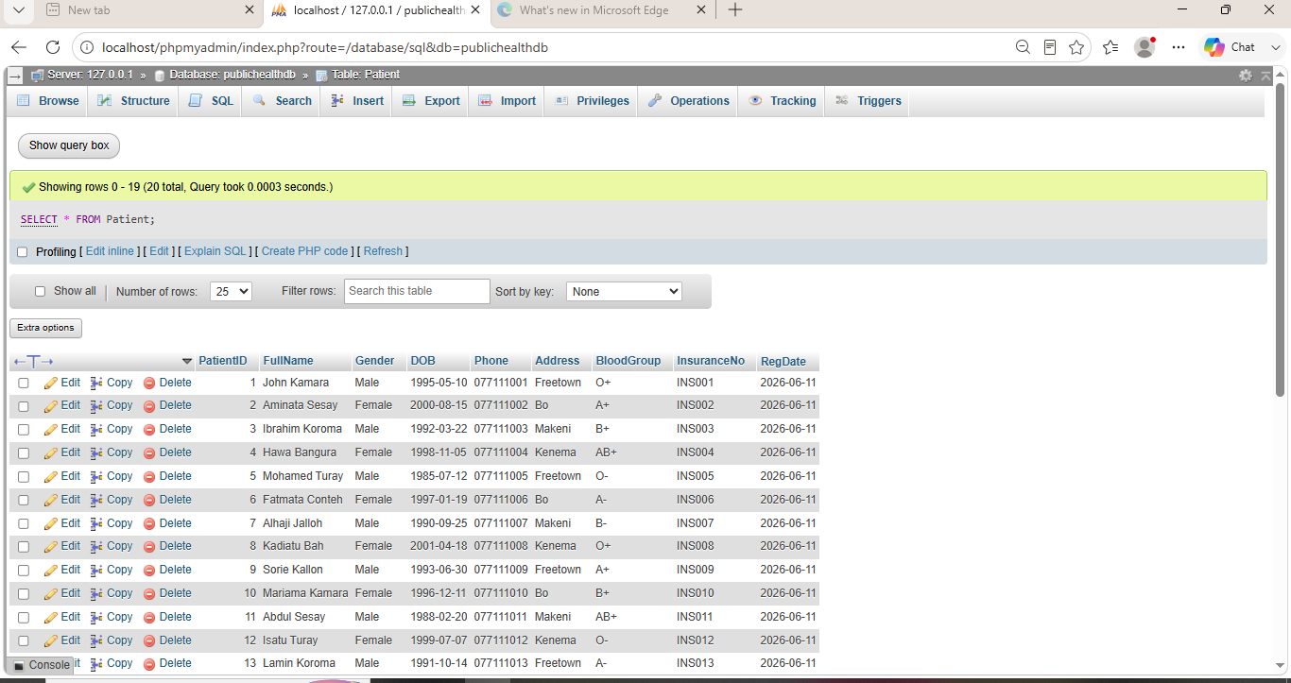
FORM

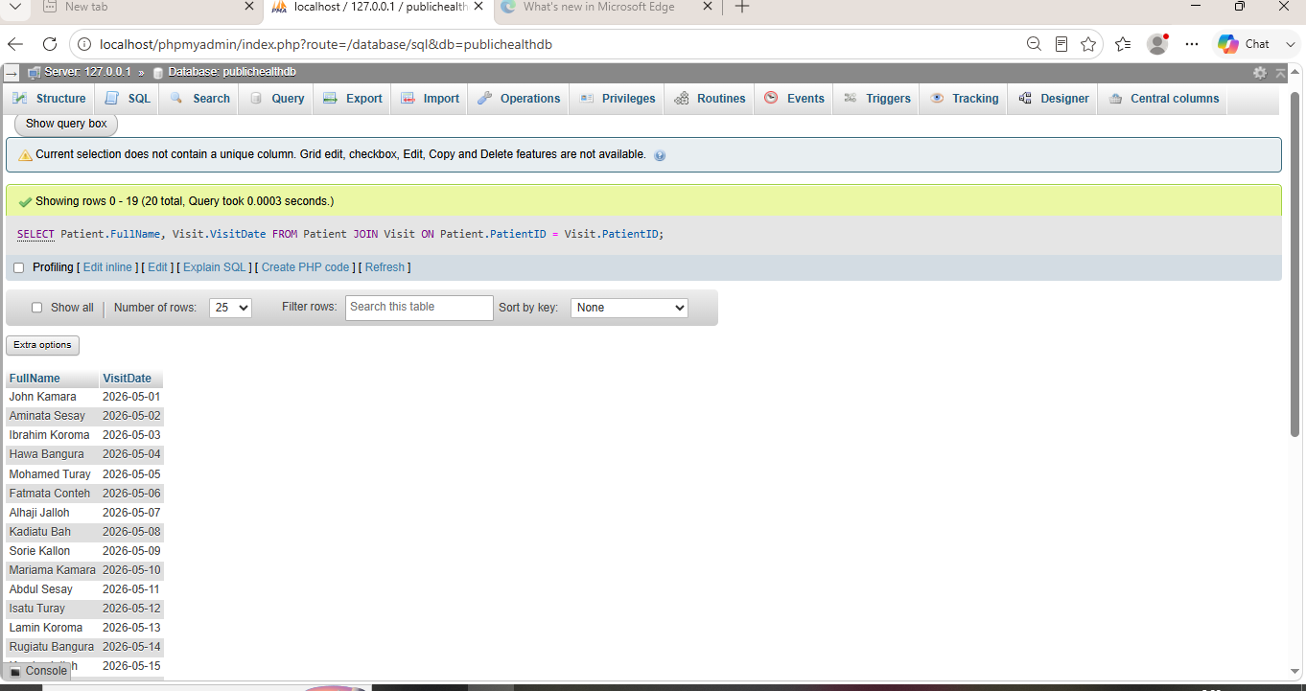
JOINED

User Management and Database Security
In this project, MySQL user management was implemented to control access to the Public Health database. Three user accounts were created for each group member: Marian, Elizabeth, and Joseph. Each user was assigned different levels of privileges based on their role.
Marian was granted full privileges, allowing complete control over the database including creating, updating, and deleting records. Elizabeth was given moderate privileges, including the ability to view, insert, and update data. Joseph was assigned limited access, with permission to only view data.
Password management was also demonstrated by modifying user credentials to enhance security. These measures ensure that sensitive health data is protected from unauthorized access and misuse.
Implementing user management improves database security by restricting access, preventing accidental data loss, and maintaining data integrity.

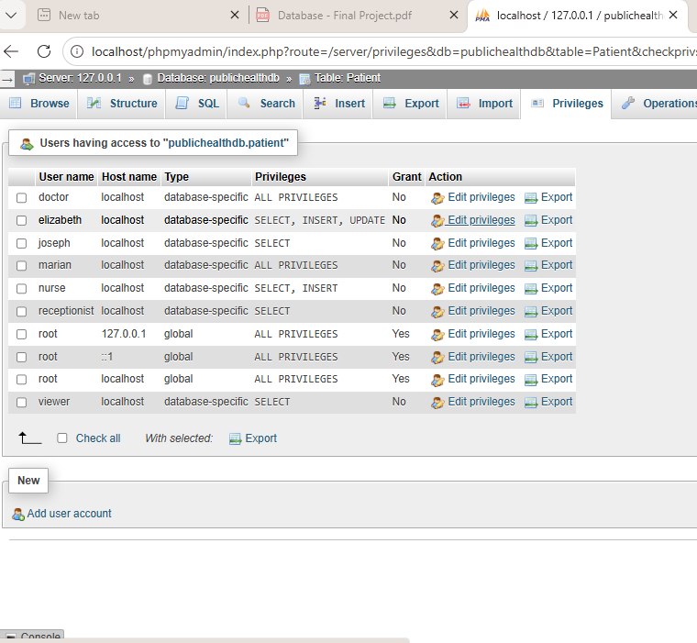
This screenshot shows the creation of users, assignment of privileges, and implementation of database security measures.

Conclusion
In conclusion, the Public Health Service Database System was successfully designed and implemented using MySQL. The project demonstrated the ability to create a relational database, define relationships between tables, and manipulate data using SQL queries.
The implementation of user management further enhanced the system by providing controlled access and improving security. This ensures that sensitive patient information is protected from unauthorized access.
Overall, the project provided practical knowledge of database design and management, which is essential in real-world healthcare systems for efficient data handling and decision-making.

